# Overview of FMW MapViewer 11.1.1.7 (V2 API) demos

## Introduction

This document provides an overview and guidelines on using the new demos packaged in the mvdemo sample application for MapViewer 11.1.1.7. It only discusses the demos of the new (V2) HTML5-based Oracle Maps Javascript API. The demos are available online at the following locations:

* <http://maps.us.oracle.com/mvdemos/> (inside the Oracle network)
* <http://slc02okf.oracle.com/> (accessible from outside the Oracle network. Uses WLS11g), and
* <http://slc02okl.oracle.com/> (accessible from outside the Oracle network. Uses Glassfish3)

The two machines slc02okf and slc02okl are Oracle Enterprise Linux 5 (64-bit) with 8gb memory running database 11gr2, with MapViewer, and the mvdemo sample application deployed, in WLS or Glassfish.

Only the demos listed on the welcome page at slc02okf/slc02okl will be discussed here. The others (at maps.us.oracle.com/mvdemos/) are older demos that may or may not work at times. The welcome page looks like the screenshot below.

The primary purpose of the demos is to show the richer interactivity and responsiveness possible with the new API.

## Using the demos

All demos require a modern browser with HTML5 Canvas support. That is Chrome 15 or later, Firefox 10 or later, IE9 or later, Safari 5 or later. Click on a link to open that demo page. Use the browser’s Back button to navigate back to the welcome page and to a new demo if necessary.

### Airports and Connections

The first demo, **Airports and Connections**, shows varying sized circles for cities (airports) and links from an airport to destination airports that have a direct flight from the source airport. The size of the circle depends on the number of direct outbound flights from that airport. The outbound links are shown from the airport that is nearest to the current location of the mouse (pointer) on the map. See the following screenshot for an example of displayed circles and links.

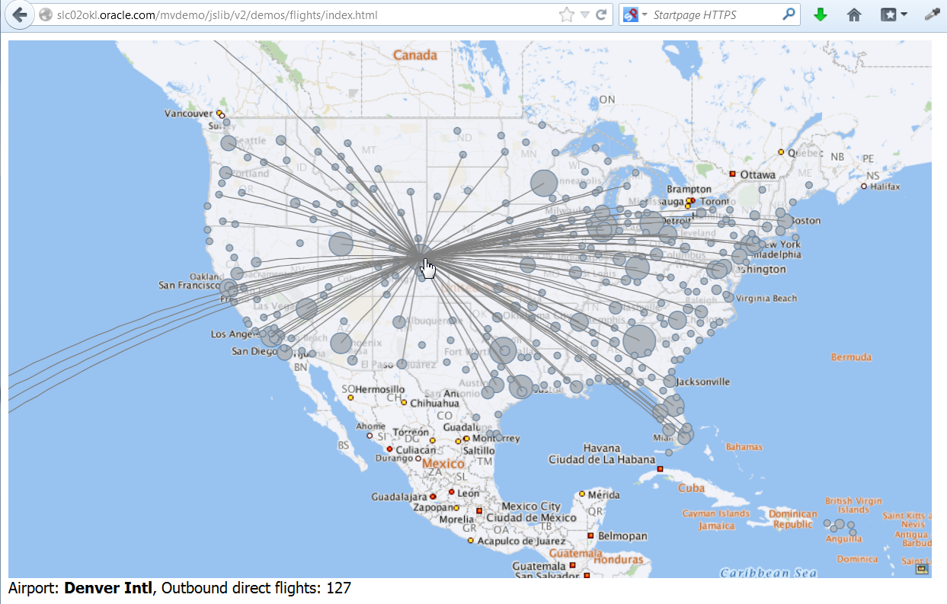

The demo shows how MapViewer can mash-up and render content from multiple sources. There are four spatial layers in this example: (i) the background map tile layer from maps.oracle.com, (ii) the non-interactive US states layer, (iii) the interactive airports layer, and (iv) the dynamic outbound connections (direct flights) layer. The map tile layer comes from an external map service at maps.oracle.com. The STATES layer comes from a local database instance. The airports layer and connections information are read from local files that are in a json format. The airports json file contains information on the airport name, location (Longitude/Latitude), and number of outbound flights. The connections file contains a list of source-destination airport pairs.

The airports and connections information is loaded into the browser as local Javascript objects (arrays). So as the user moves the mouse the search for the nearest airport location is done locally in the browser and there is no server round trip. Once the nearest airport is found the application looks up the connections from that airport (i.e. uses the array of source-destination pairs) and dynamically creates a temporary layer to display the outbound flight links from that airport. When the user moves the mouse again, the current dynamic outbound flights layer is removed, and a new one is created and displayed for the airport nearest to the updated mouse location.

### Map Templates

The **Map Templates** demo shows the use of json files (for spatial content) and a configuration file specifying the map metadata. The template config file contains information on the initial map center and zoom level, the tile layer(s), the vector layers (aka themes), the styles, and the (hierarchical) relationship between the spatial layers, if any.

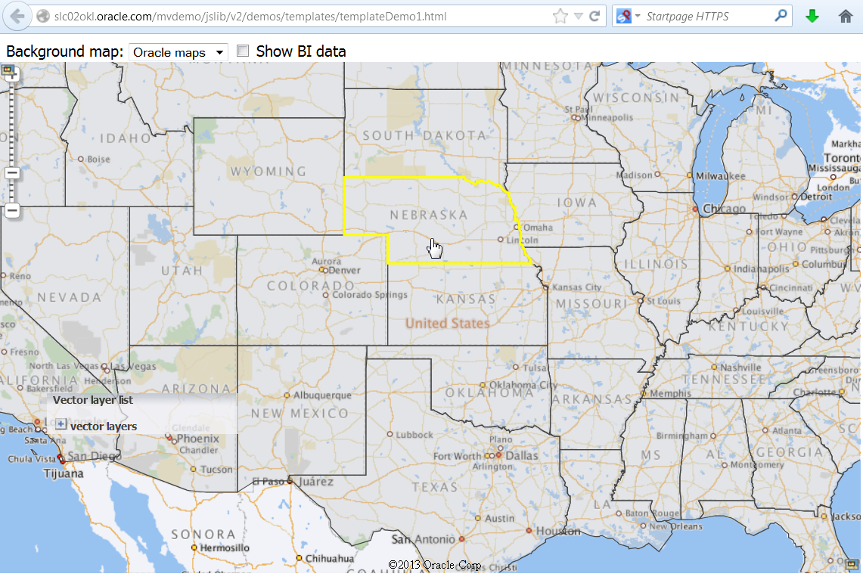

To show the template config file open a new browser tab or window, copy and paste the url for the map templates demo and replace templateDemo1.html with template1_config.json. For example, on slc02okl (as shown above) the url for the template config file would be: slc02okl.oracle.com/mvdemo/jslib/v2/demos/templates/template_config.json. Hit enter to load that file and it should look like the screenshot below.

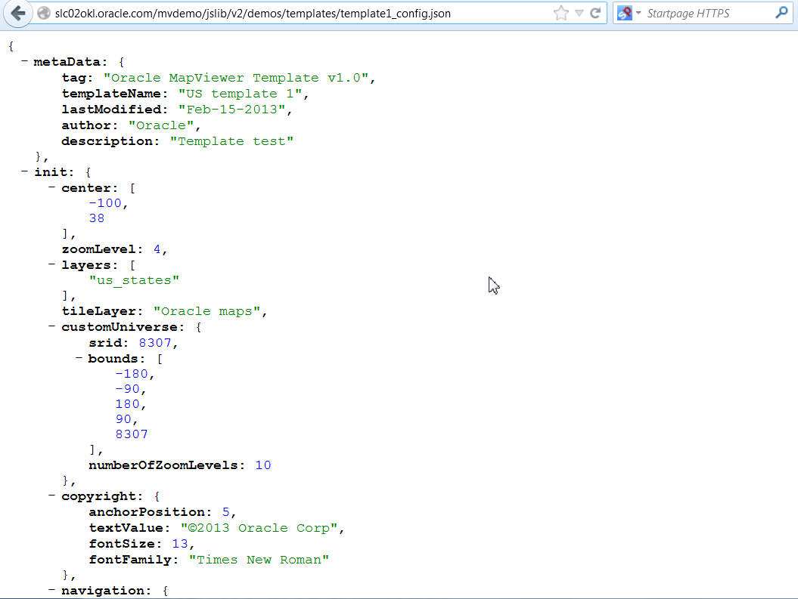

The template config file specifies that the background map tile layer is from maps.oracle.com (Oracle Maps), the initial map center is {Longitude:-100, Latitude:38}, the initial zoom level is 4, and that the US States layer is also displayed.

The remainder of the config file contains information on the other layers which can be displayed and the styles used in rendering these vector layers. The relevant snippet of file is:

vectorLayers": [  
{  
"dn": "us_counties",  
"uri": "/mvdemo/datapacks/usa_counties.json",  
"cn": [

"USA Counties",  
"US counties",  
"United States Counties",  
"Counties of USA"  
],  
"pl": [  
"us_states"  
],  
"styles": {  
"normal": "mutedColor1",  
"mouseOver": "hoverColor1",  
"selected": "selectedColor1"  
}},  
{  
"dn": "us_states",  
"uri": "/mvdemo/datapacks/usa_states.json",  
"cn": [  
"USA States",  
"US states",  
"States of USA",  
"States"  
],  
"cl": [  
"us_counties",  
"us_airports"  
],  
"styles": {  
"normal": "mutedColor1",  
"mouseOver": "hoverColor1",  
"selected": "selectedColor1"  
}},  
{  
"dn": "us_airports",  
"uri": "/mvdemo/datapacks/us_airports.json",  
"cn": [  
"Airports",  
"US airports",  
"Airports of USA"  
],  
"pl": [  
"us_states"  
],  
"styles": {  
"normal": "marker1",  
"mouseOver": "pulse1"  
}}  
],

All three layers are in json files and States is the parent (pl) layer while Counties and Airports are a child (cl) layer. The styles themselves are also defined in the config file.

styles": [  
 {  
 "dn": "mutedColor1",  
 "type": "color",  
 "def": {  
 "fill": "#cccccc",  
 "strokeThickness": 1,  
 "stroke": "#444444",  
 "fillOpacity": 0.4  
 }  
 },  
 {  
 "dn": "hoverColor1",  
 "type": "color",  
 "def": {  
 "strokeThickness": 2.5,  
 "stroke": "#ffff00"  
 }  
 },  
 {  
 "dn": "selectedColor1",  
 "type": "color",  
 "def": {  
 "fill": "#cccc00",  
 "fillOpacity": 0.3  
 }  
 },  
 {  
 "dn": "marker1",  
 "type": "marker",  
 "def": {  
 "width": 15,  
 "height": 15,  
 "src": "/mapviewer/icons/pointer_pin_ora.png"  
 }  
 },  
 {  
 "dn": "pulse1",  
 "type": "pulse_animation",  
 "def": {  
 "stroke": "#336699",  
 "duration": 1,  
 "beginSize": 8,  
 "endSize": 50  
 }  
 }, …

This demo also shows the use of the built-in layer control and the non-spatial data provider feature. Click on the + symbol next to Vector Layers in the Layer Control map decoration. You’ll see the US Airports, US Counties, and US States layers listed. Only the States layer is checked and hence displayed. Click on the checkbox next to US Airports and you should see something similar to the screenshot below.

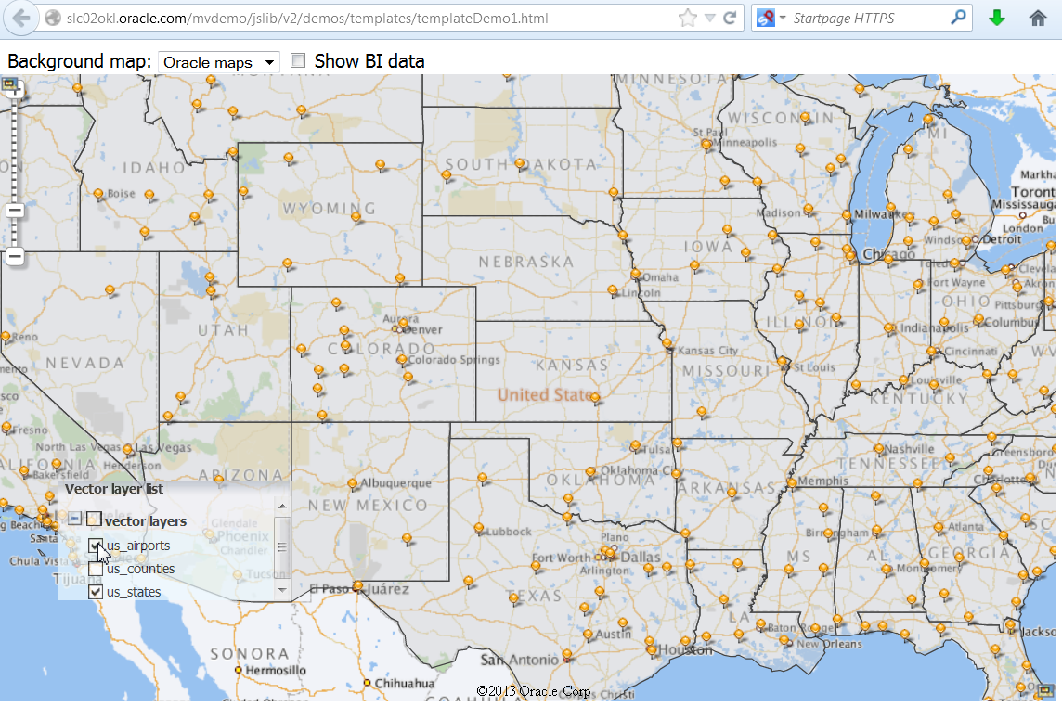

The NSDP (non-spatial data provider) is the MapViewer functionality used in OBIEE (Oracle BI Suite) to relate and display a BI report on a map. The BI report will typically contain a location or area identifier (such as an airport code or state name) and a metric (such as number of outbound flights or annual sales tax revenue). Click on the checkbox next to Show BI data and the states will be color-coded by revenue as shown below. Not all states are in the BI report so not all states will have a color-fill.

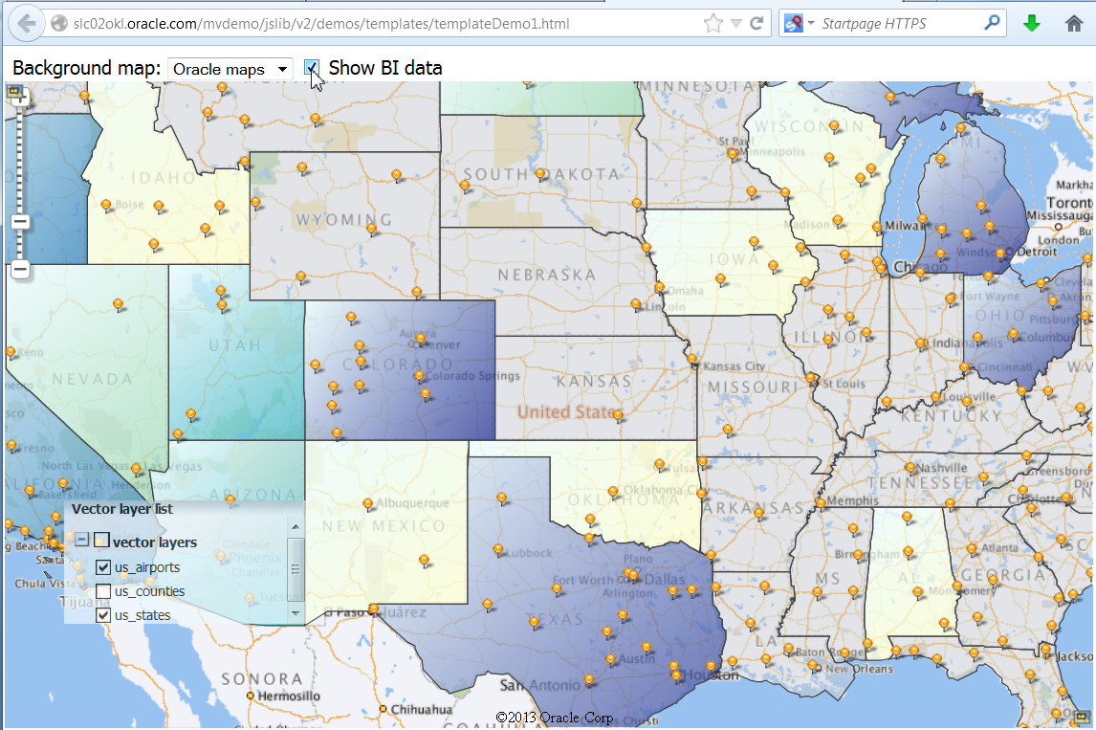

The BI data and the color fill style are defined in the Javascript code to demonstrate the use of API (Use View Page Source in the browser to see the Javacsript code).

The Background Map dropdown is disabled. So selecting Bing, Google, or Nokia via the dropdown list will have no effect.

### Storm Data Analysis

The **storm data analysis** demo highlights the following features of the V2 API:

* ability to switch between background map tile layers,
* display a zoomable interactive thematic layer without any background map tile layer,
* select interactive features on the map using a selection (circle/rectangle/polygon) tool,
* auto-clustering and aggregation of point features, and
* heatmaps

The initial display will look as shown below (minus the highlighted portions).

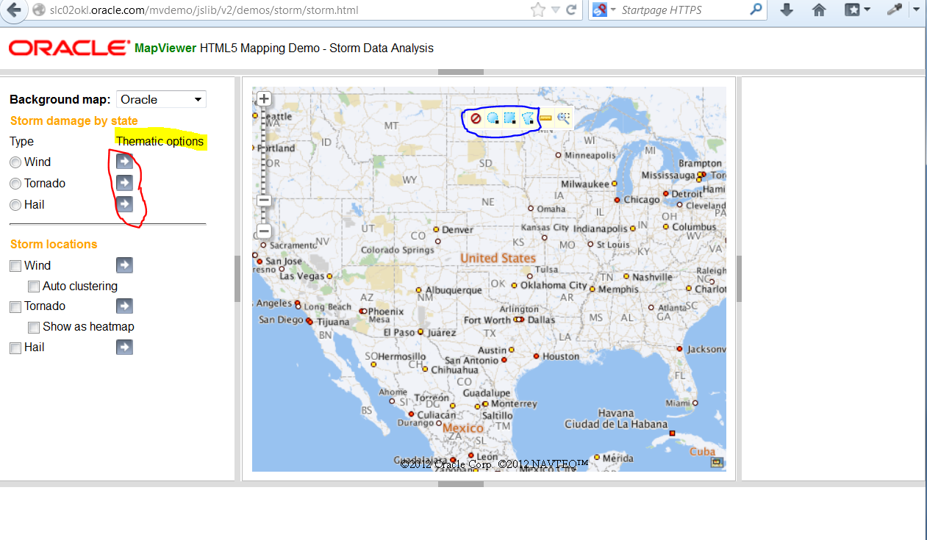

The storm damage by state section (top portion of the left panel) is used to display the aggregate loss, fatality, or injury value by state for a given year. Clicking on the arrow symbol, under thematic options (highlighted in yellow above), for a selected storm type will bring up a dialog panel for choosing the color scheme and the metric (property or crop loss, injuries, or fatalities). The storm locations section is used to display individual storm incidents for all years (1996 – 2010). Clicking on the arrow marker next to a storm type brings up a dialog box for specifying attribute filter criteria (e.g. number of fatalities is more than 4). The spatial selection tools (the circle, rectangle, and polygon shown in the toolbox highlighted in blue) are used to select individual storm incidents that lie within the user-drawn area of interest.

The demo dataset consists of storm (wind/hail/tornado) damage information (location, crop and property loss in millions, number of fatalities, and date of occurrence) from 1950 till 2010 (only data for 1996 through 2010 is used in the demo itself). All data is stored in database tables in the storm schema that is part of the storm sample dataset.

A typical demo workflow is as follows.

Select a storm type (i.e. click on the radio button), say wind, in the storm damage by state section. The states layer will be shown with no color-coding (screenshot below). A timeline, for selecting the year, will show up in the bottom panel and 1996 will be highlighted. Next click on the arrow marker and choose the thematic attribute, color scheme, and border line style (second screenshot). Choose Loss (or Injuries) as the attribute column, either of the two color ramps (classes), and change the Line Color to a lighter grey, click on Submit (third screenshot) and close the dialog (click on the X in the upper-right) to view the result (fourth screenshot below).

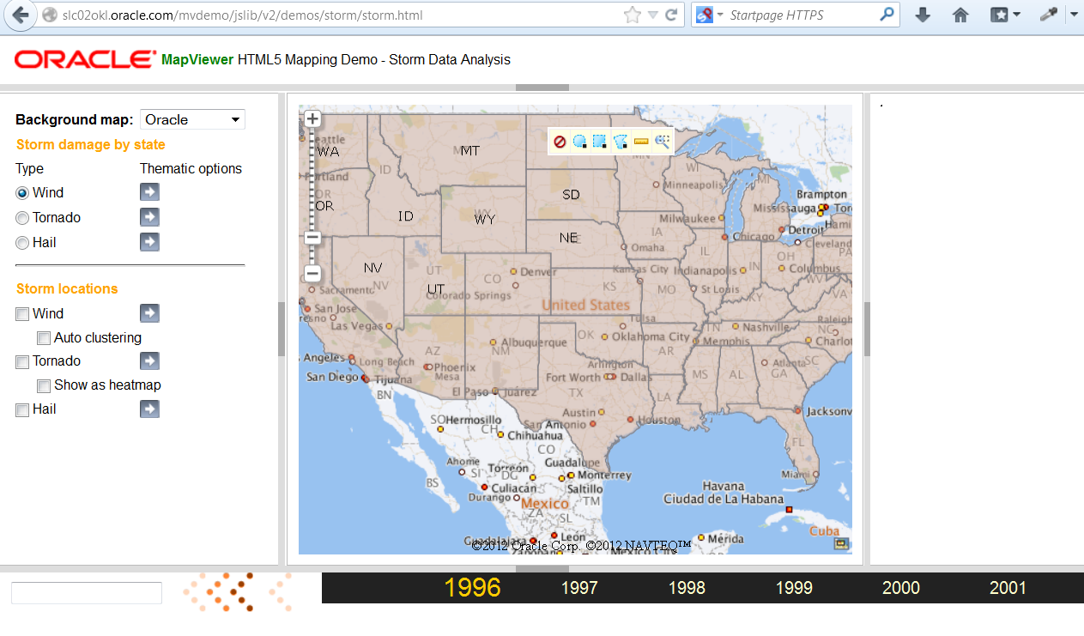

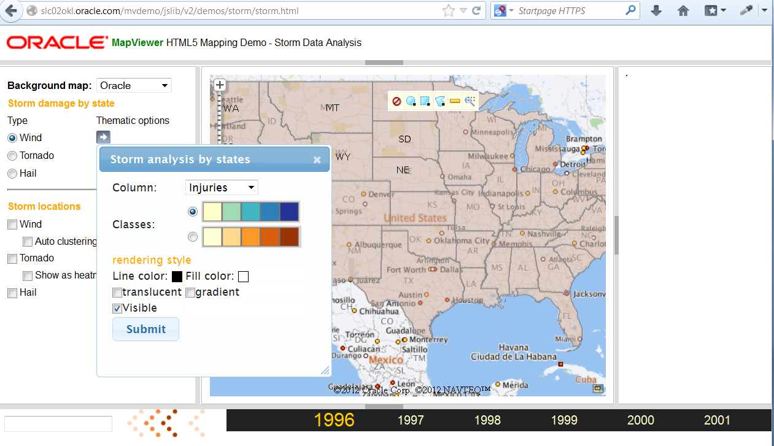

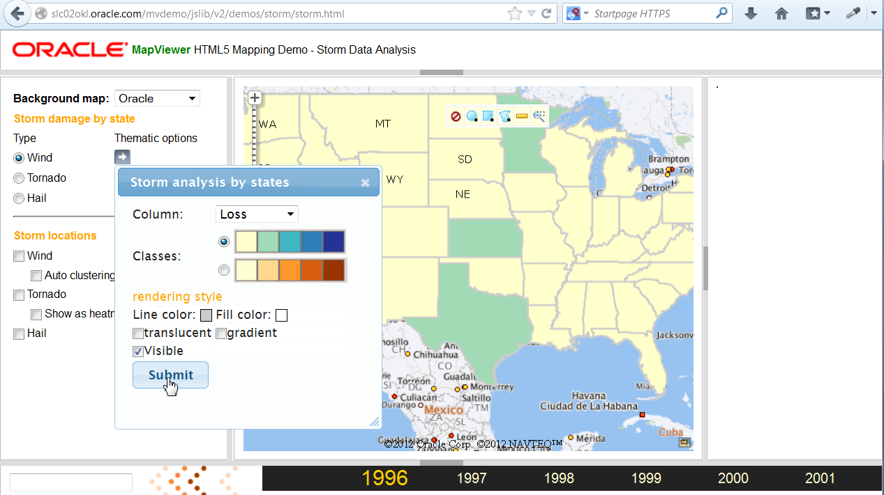

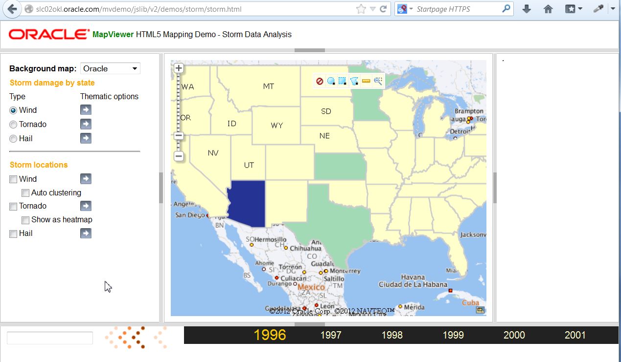

Now click on a year in the timeline (e.g. on 1999) and the map will update to show property loss by state due to wind storm damage in that year.

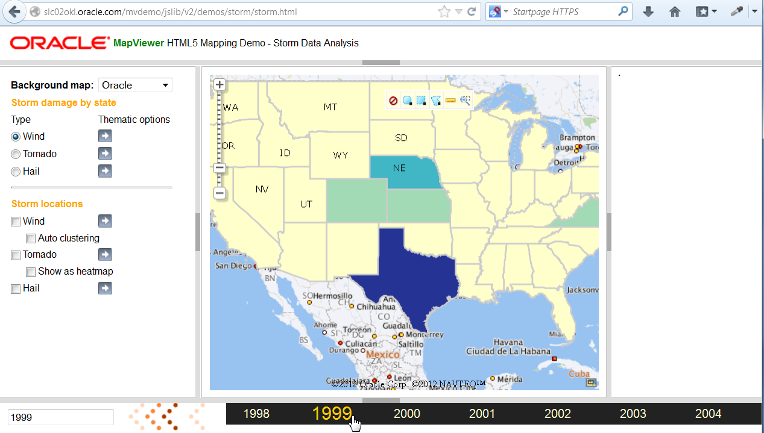

Try other years. Next click on the background map dropdown list and select a different one (e.g. Nokia).



Or choose Thematic to display the storm damage by state and year without any background tile layer.

Due to a bug in the demo you will need to click on the arrow symbol (next to Wind) to enable the thematic options again. Leave the defaults (which should be loss and light grey line color) and click on submit and exit the dialog).

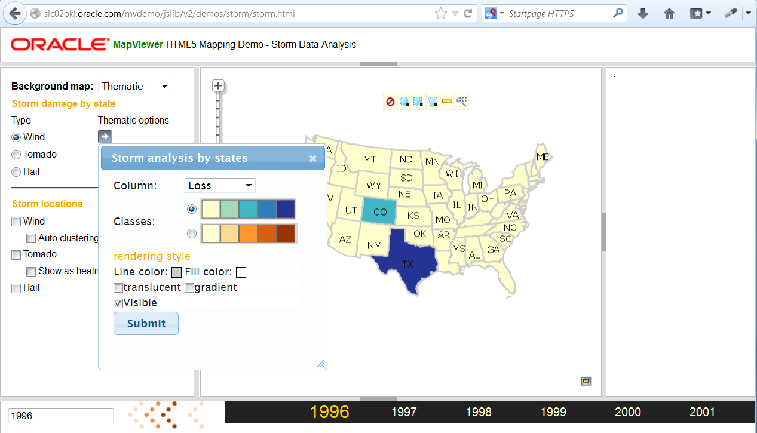

Click on different years and the map will update. Now choose a map tile layer (Oracle or Nokia) again. Click on the thematic options and uncheck Visible to hide the storm damage thematic layer, click Submit and exit the dialog.

Then click on the Wind checkbox in Storm locations.

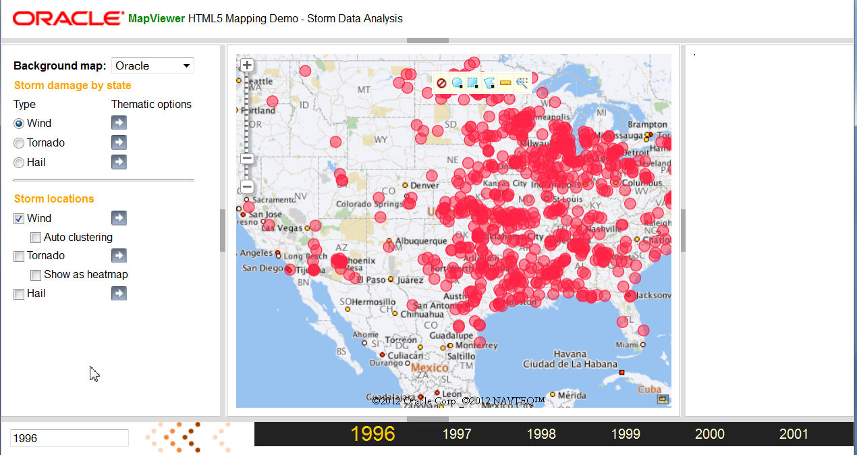

As you mouse-over an incident location it will be highlight (the marker symbol is larger). Choose (click on) the polygon (aka redline) tool in the toolbar.

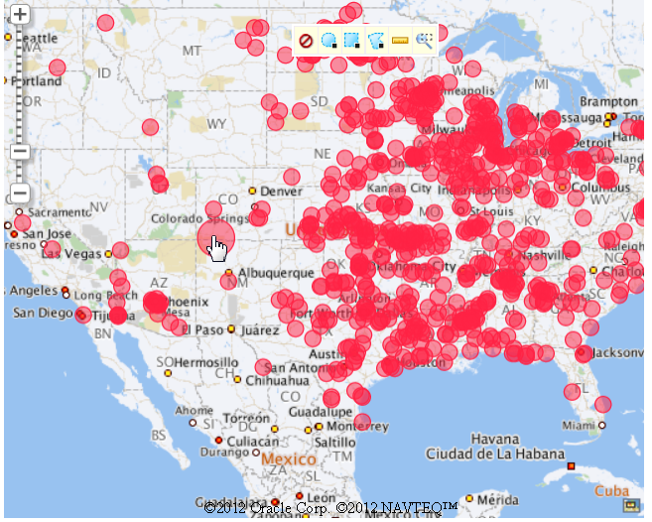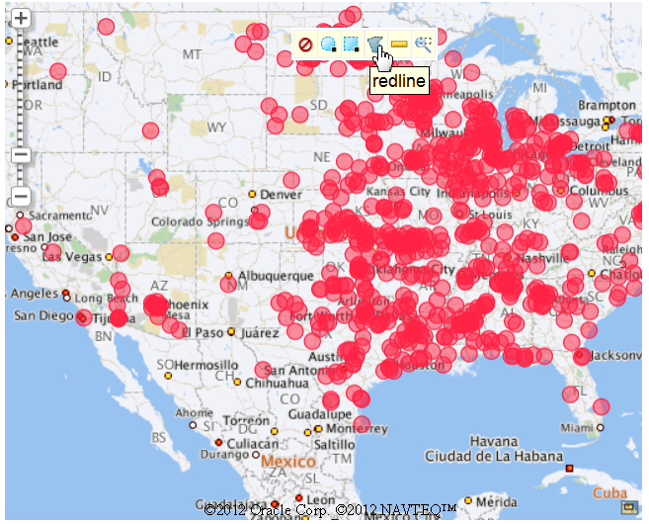

Then start drawing a polygon to select storm locations. Click the left-mouse-button to specify three or more vertices for the polygon and then rt-click to end. The locations inside that polygon will be highlight in yellow and the right panel will display a table showing details for each selected incident.

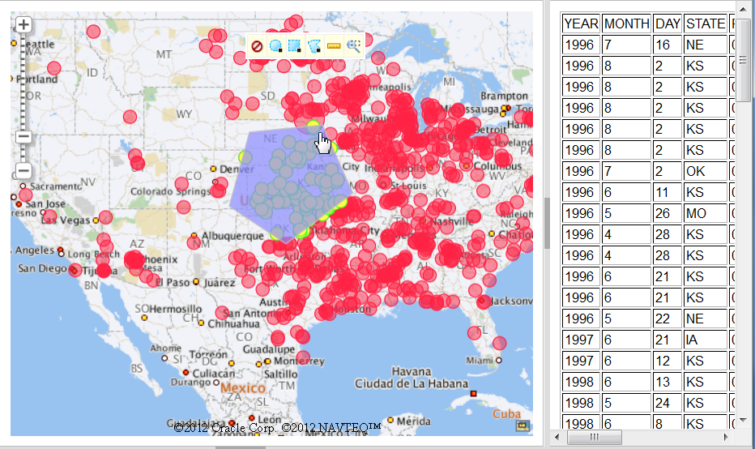 Now click inside the polygon you drew and you should its vertices displayed. Click and hold the left mouse button down within the polygon, drag the mouse and release. The polygon should move and the highlighted incidents and table on the right will be updated. Note that the first entry is now for a windstorm in Indiana (instead of Nebraska above). Or that the table shows storm in IN, IL,OH, WI, and IA instead of NE, MO, KS, OK, and IA.

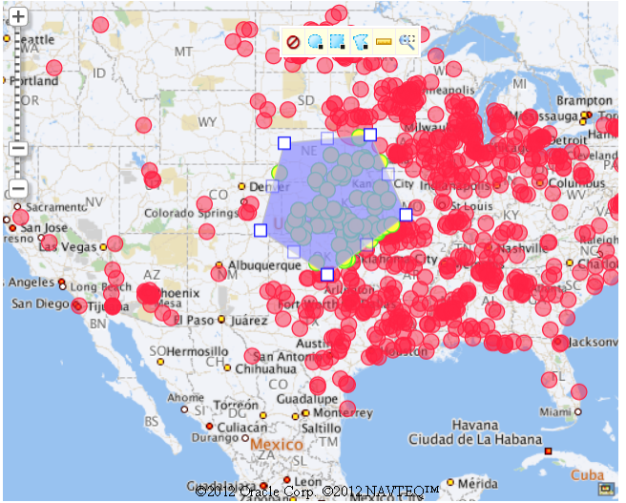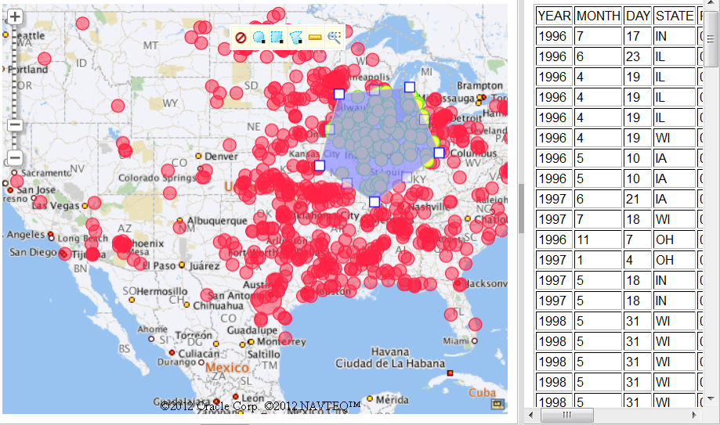

Now click on one of the vertices for the polygon and drag the mouse to move the vertex, and release. The polygon shape will change and the selected features, and corresponding table, will be updated. This demonstrates the new redlining capabilities of the V2 API.

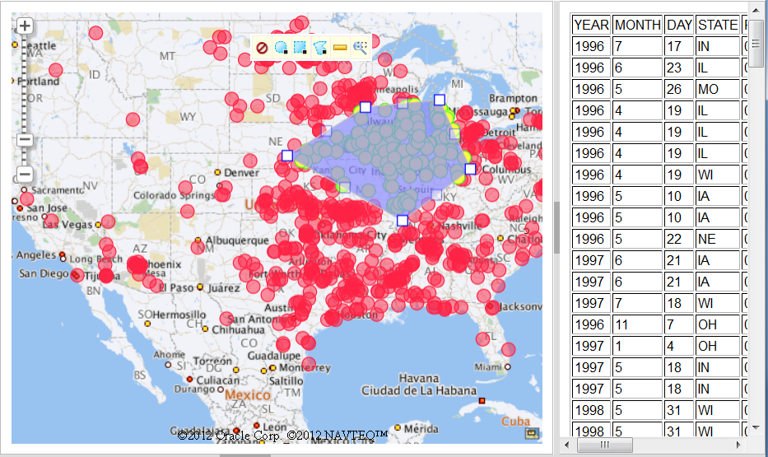

Now click on the red circle in the toolbar (leftmost icon) to clear the polygon, selection, and table. Click on the auto-clustering checkbox to enable it.

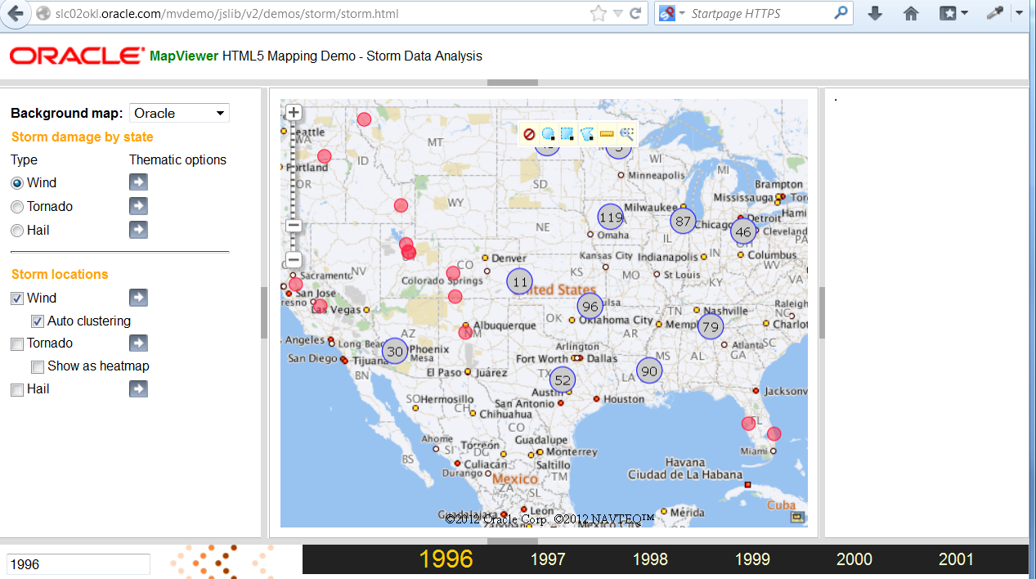

Click on one of the aggregate symbols (e.g. the 119 in Nebraska) and the map zooms in and auto-clusters again.

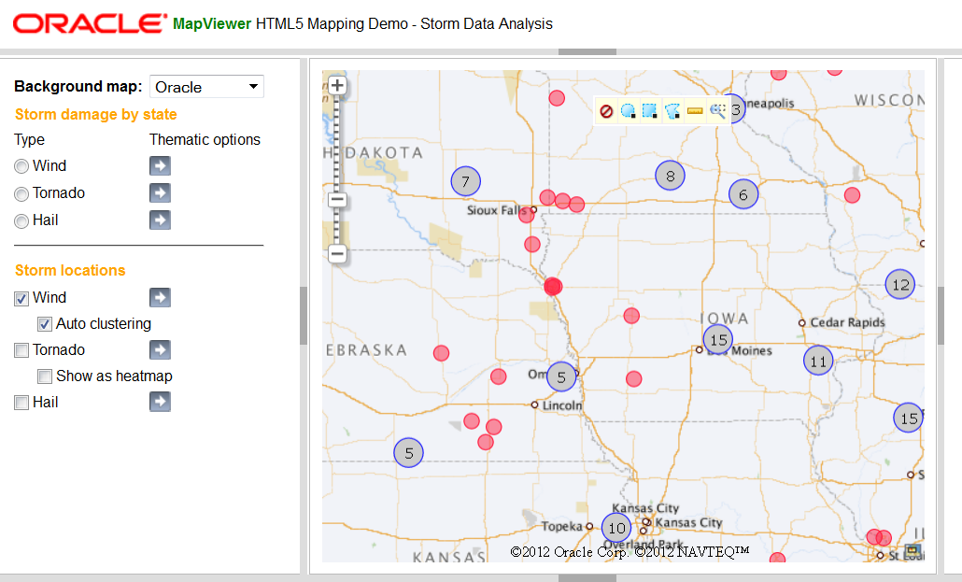

Uncheck the auto-clustering and wind and select tornado, zoom out one or two levels by clicking on the ‘-‘ in the navigation bar, and then show as heatmap instead.

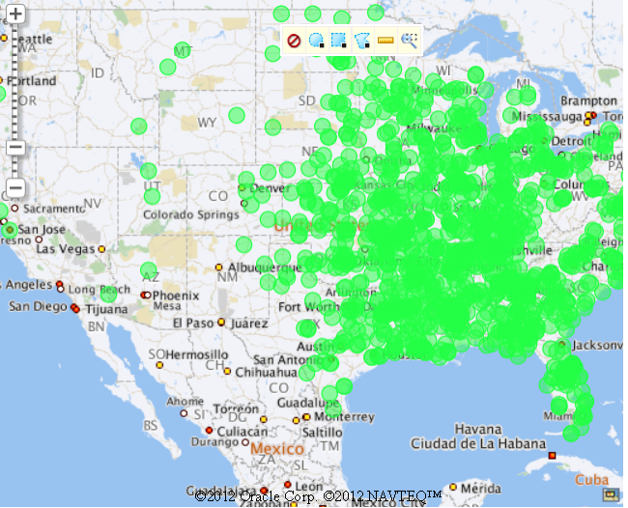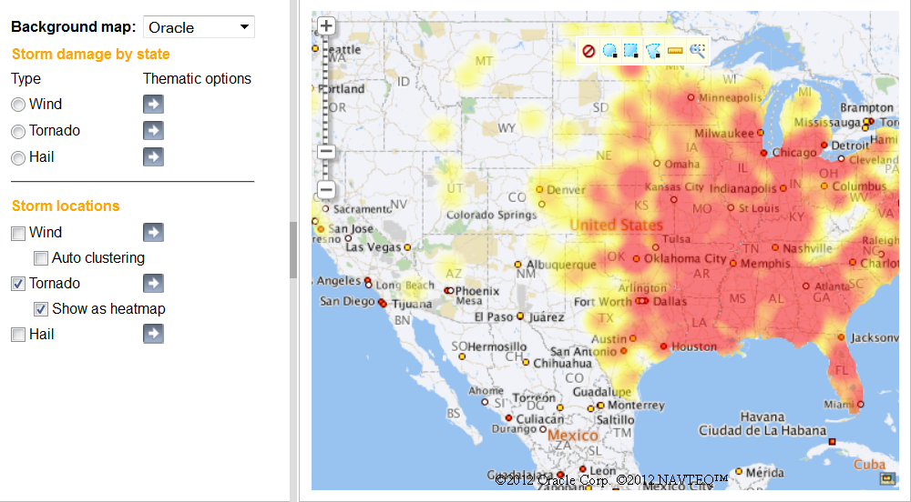

At a last, optional, step uncheck show as heatmap and click on the arrow symbol to bring up the attribute filter dialog. Enter 1 and 4 as min and max values for Fatalities and click Apply Filter.

### Storm Data Trellis View

The **storm data trellis view** shows a subset of the storm damage (property loss) by state and year data but as a 2-d grid of interactive thematic maps by storm type and year. The maps may take 2-3 seconds to show up as there are 12 of them on this page.

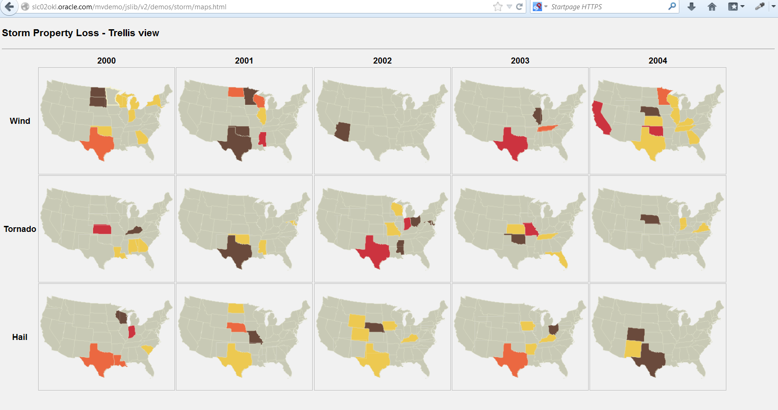

### State/County population

The **state and county population** demo shows the thematic mapping capabilities of the new API. States are color-filled based on their total population and the selected style. The style specification consists of the number of buckets (i.e. ranges) and a color palette (i.e. which color is used for which bucket or range).

The initial display shows a style with a gradient effect. Select a different color palette from the dropdown list (e.g. YellowBlue3 to choose a style with 3 buckets and a Yellow to Blue color ramp). Right-click on a state and the counties within that state are rendered using the selected style.

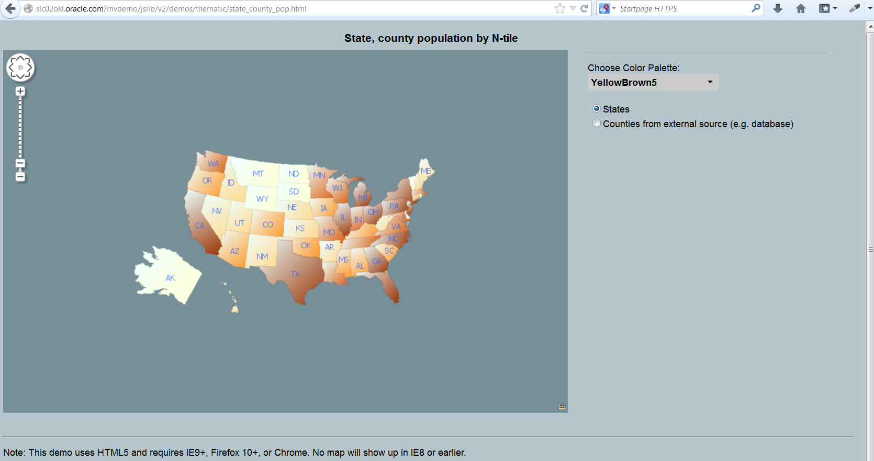

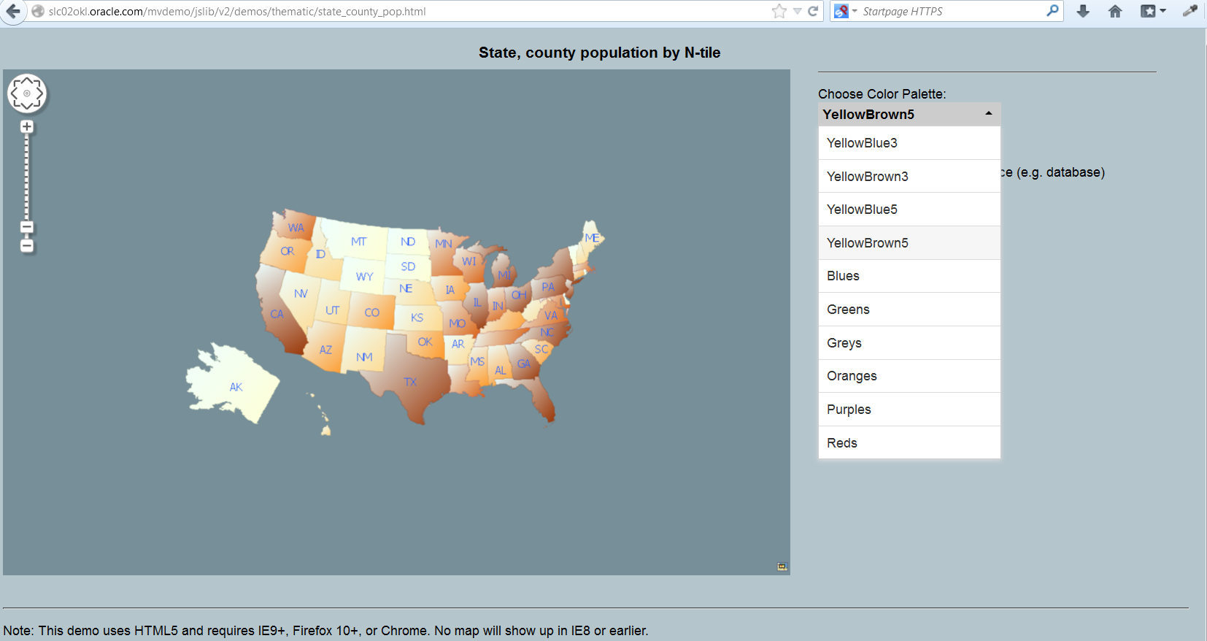

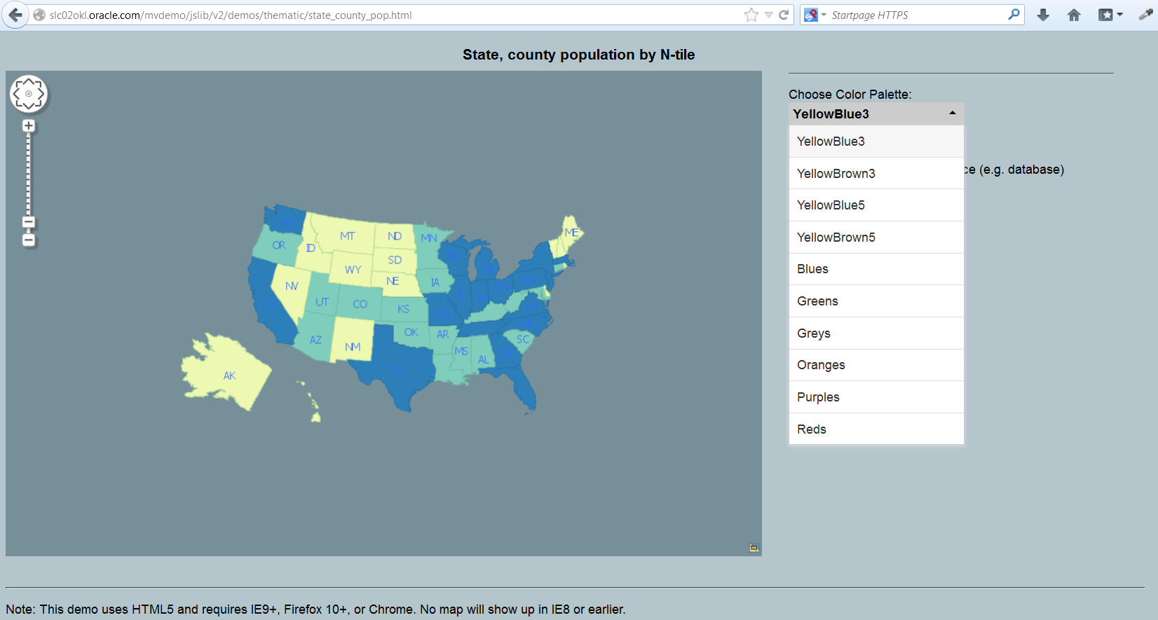

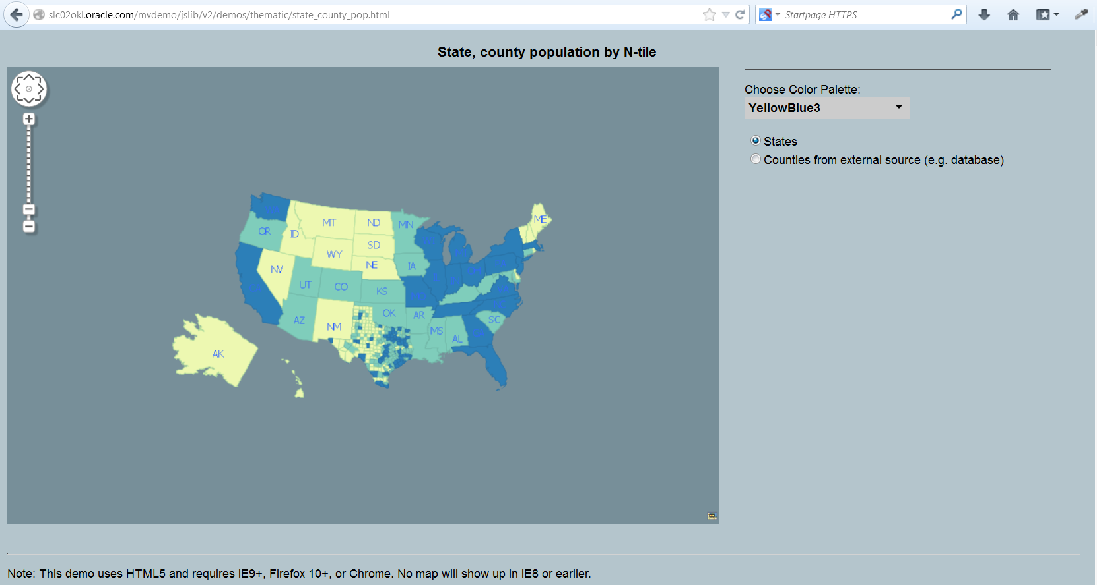

This demo showcases the dynamic styling and thematic mapping functionality. The styles are all defined at runtime on the client and applied to the states or counties layer in the client without any server round trips.

USA Travelers

The US traveler abroad (in 2009) also showcases client-side styling and interactivity. The publicly available dataset is the number of US visitors to each country in 2009. The lines (from Washington DC to the capital of the visited country) are color coded by deciles. When you hover on any line the destination country is highlighted. This demonstrates the interactivity and event handling capabilities of the Javascript API.

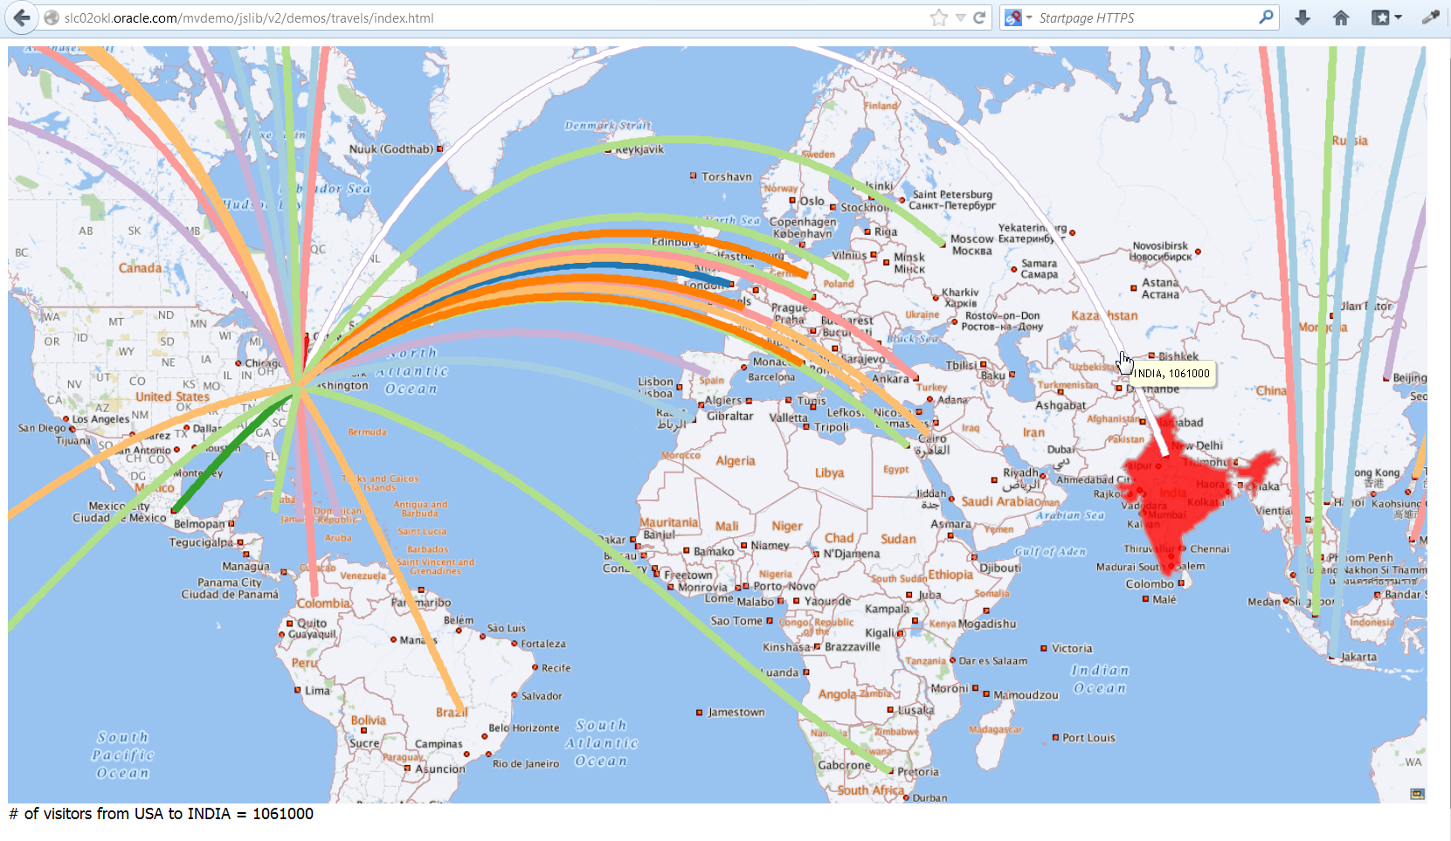

### API Tutorials

The last demo is a set of tutorials that show how to use various API methods. It starts with the basics of displaying a map, adding a navigation panel, and builds up to more complex methods such as dynamically defining styles for vector layers. This is meant for application developers who want to get started, or experiment, with the API.

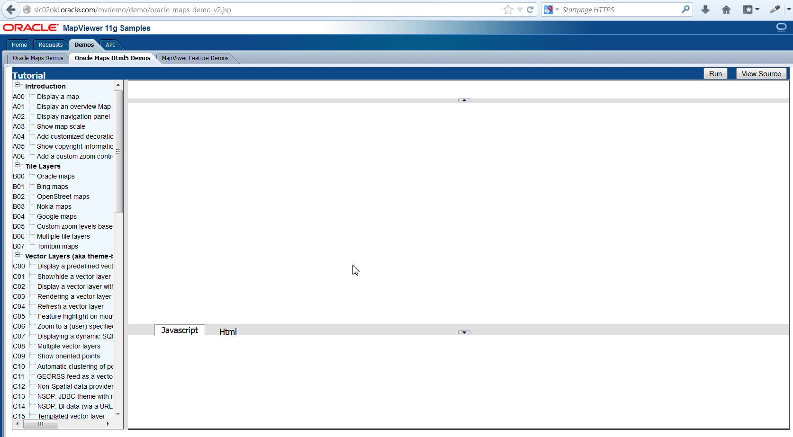

Click on a tutorial title in the left panel (e.g. Display a map) and the source code is shown in the lower right panel while the resulting map display is shown in the upper right panel.

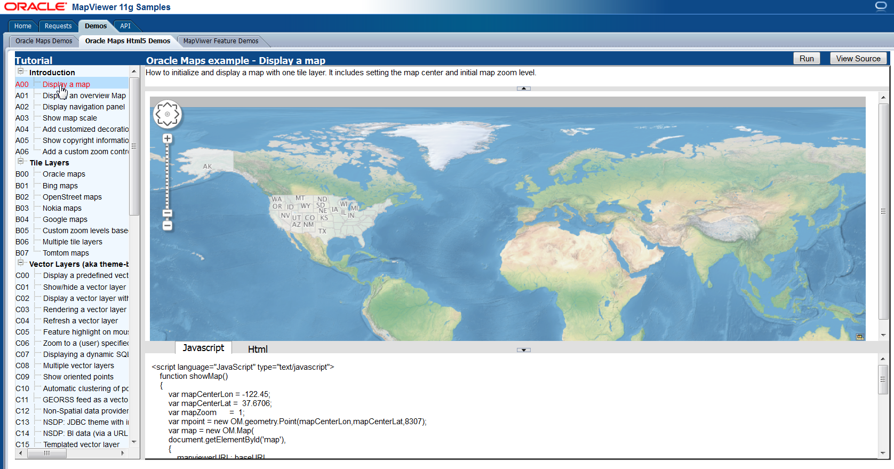

Change some values in the Javascript code shown (e.g. change mapZoom to 3 and mapCenterLon to -77 and mapCenterLat to 45) and click the Run button on the upper-right to see the effect of the code changes.

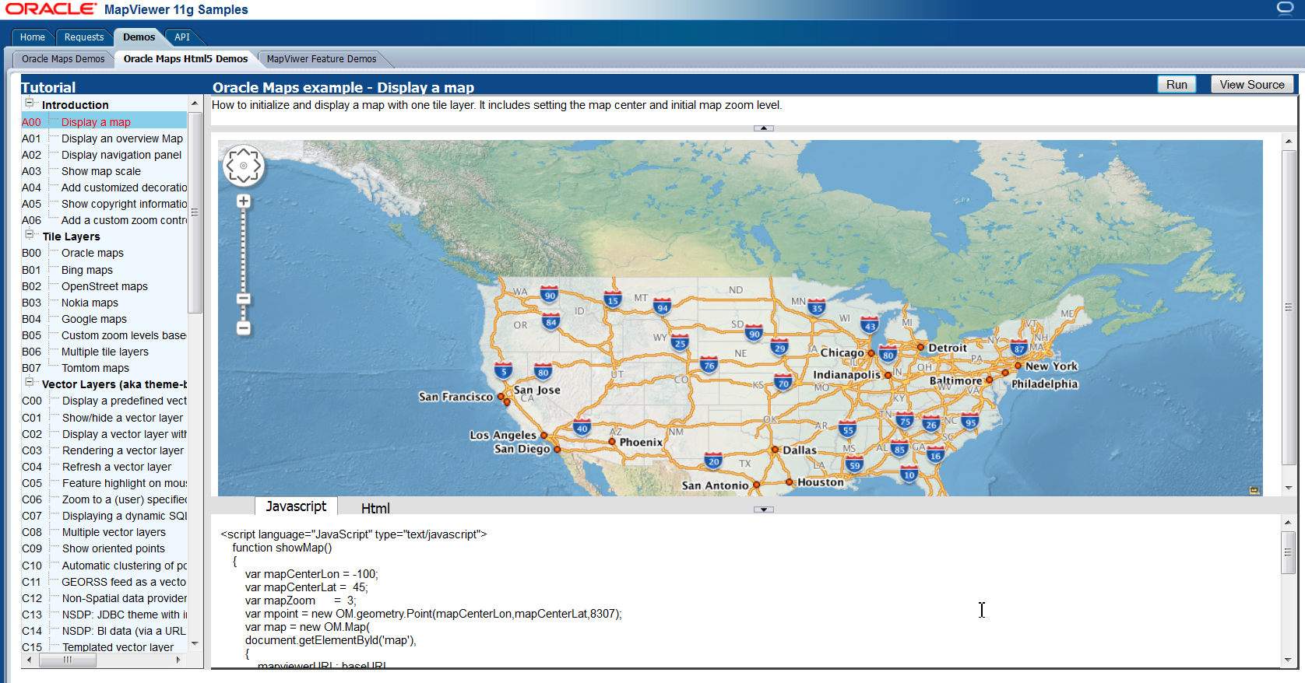

Try some of the other demos from the list on the left.